**Mainframes DXC Australia**

**Assessment 7: Storage Admin**

**By: Pranay Yara**

**16/08/2024**

**Create a PDS by name USERID.WEEK7.LABTEST**

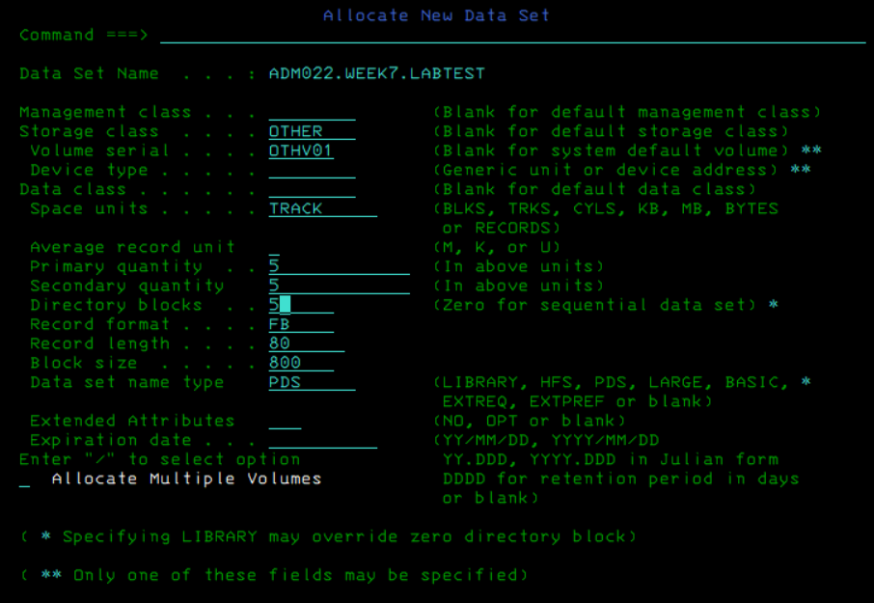

**1) Create a Member JCL001 in which write a JCL to create any two Aliases GEN##$$ in any User catalog**

**where ## denotes last 2 chars of your Userid and $$ is a Sequence number**

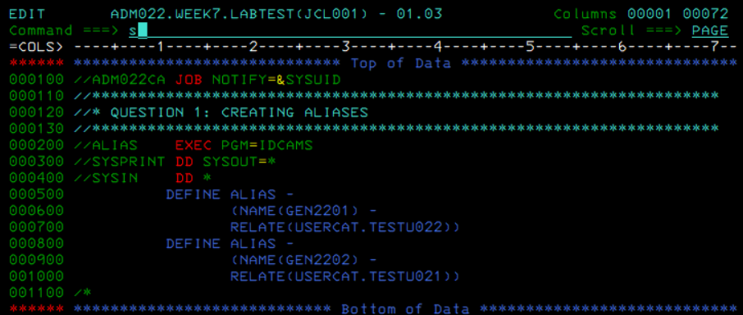



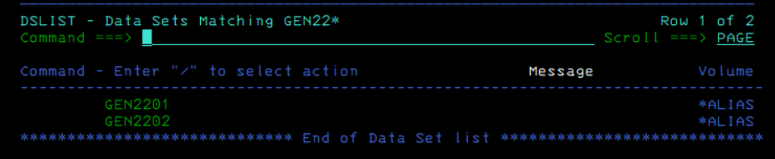

**2) Create a Member JCL002 in which write a JCL to delete the Aliases created in Step1**

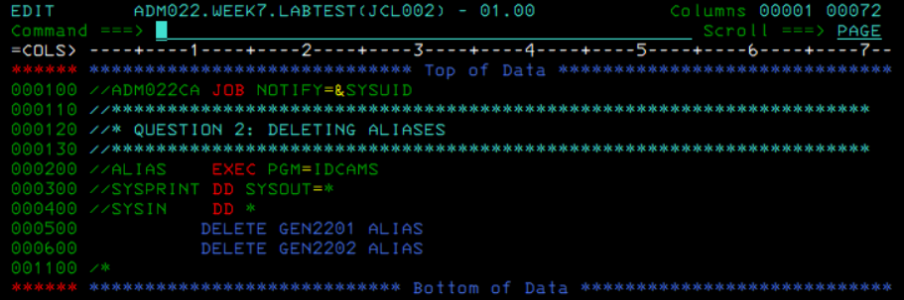



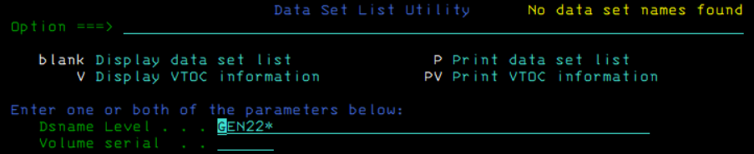

**3) Take any of your KSDS file and code a REORG Job.**

Input KSDS and backup PS:

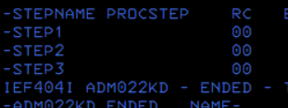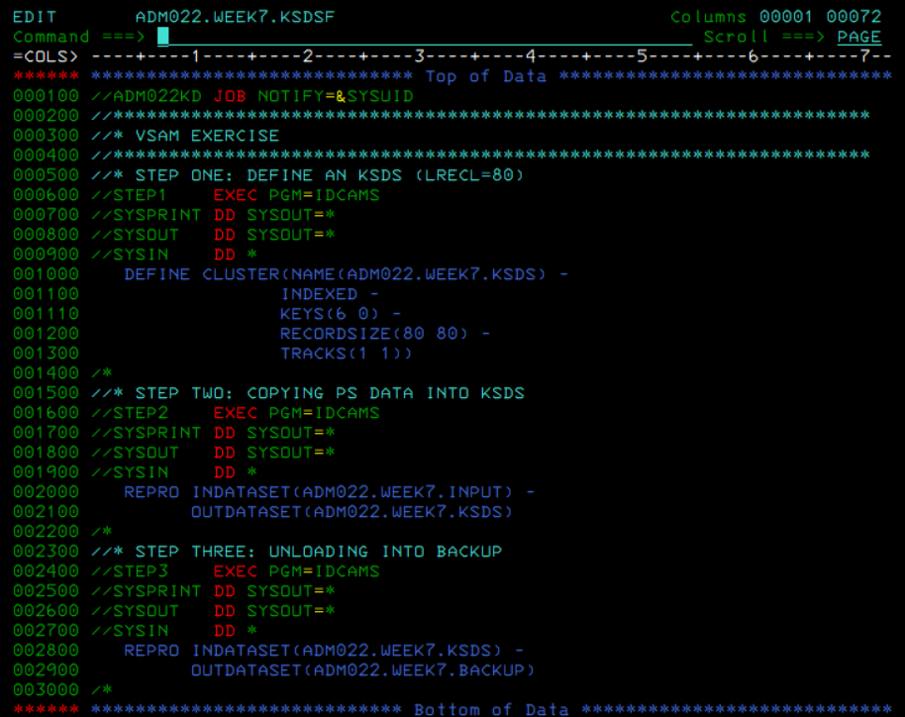

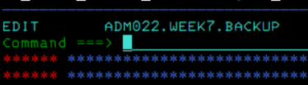

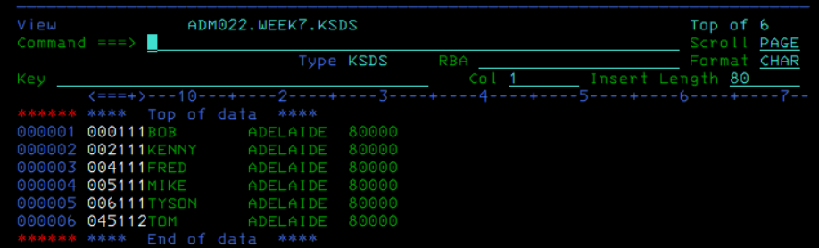

Reorg Job:

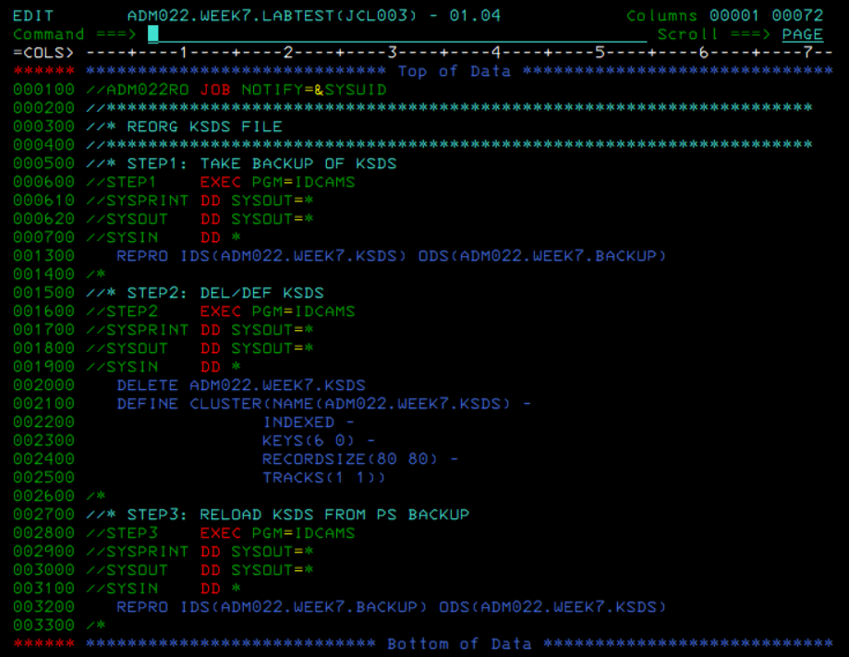

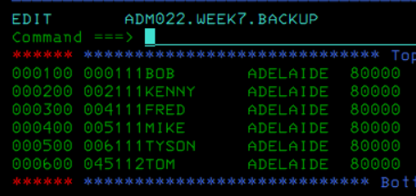

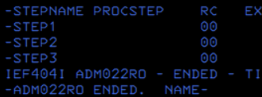

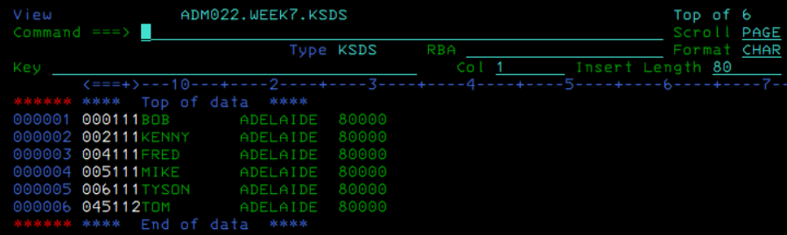

**4) Define Listcat for master catalog SYS9.SYSPRDPX.MASTRCAT**

Initially, I tried with ‘ALL’ but I got max cc 4 warning. So, I tried other commands by removing ‘ALL’ and it executed with max cc 0. I also reviewed recordings and saw we used ‘UCAT’ so I tried that command as well.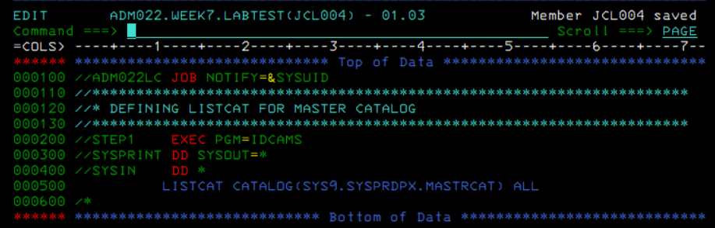

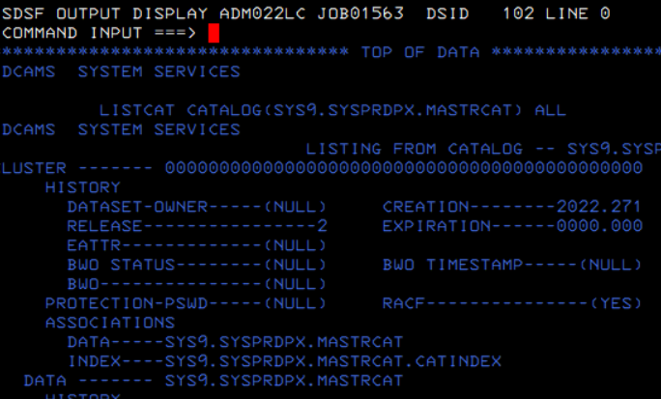



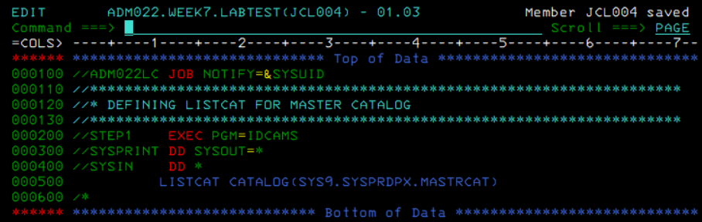

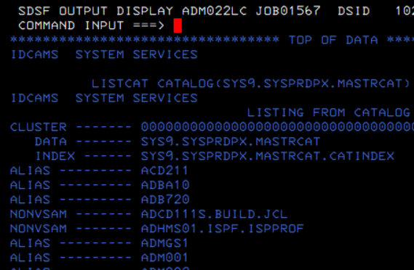



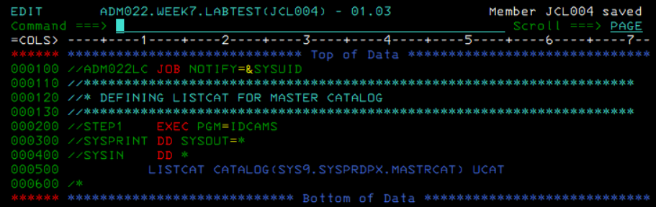

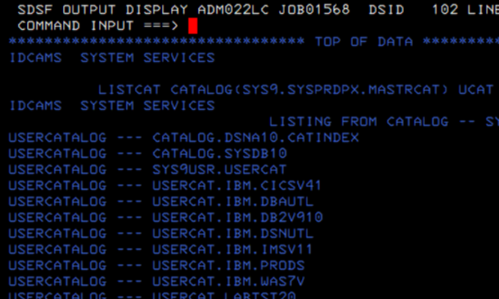



**5) Define Listcat for user catalog SYS9USR.USERCAT**